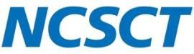

Inpatient training resources feedback form
We welcome any feedback you may have on the Inpatient Tobacco Dependence Adviser Training Resources. If you have any corrections, suggestion or comments about the training suite then we would be very grateful if you could use this form.
Please submit this form to: enquiries@ncsct.co.uk

General comments:
Document, page/slide number | Corrections, suggestions and comments

Thank you.

